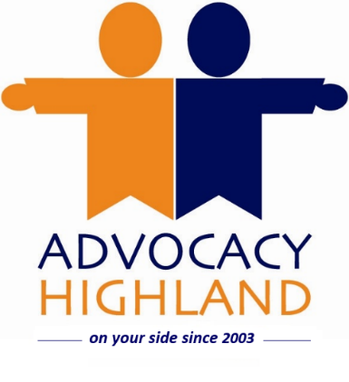

Chief Executive Officer – Recruitment Information
Are you passionate about amplifying voices and protecting rights? Advocacy Highland is seeking a visionary leader to take on the role of CEO, guiding our organisation into the future. This is your chance to lead a team dedicated to delivering high-quality, independent advocacy across the Highlands, ensuring that individuals, especially those who are vulnerable or marginalised, can make informed choices and have their voices heard.
We are looking for a dynamic and inspirational leader who shares our commitment to independence, inclusion, and human rights, and who can drive our organisation forward with energy, creativity, and compassion.

About Advocacy Highland
Founded in 2003, Advocacy Highland is a registered charity providing localised independent advocacy across the Highland Council area. We are dedicated to providing independent, one-to-one, issue-based advocacy and have advocacy workers based throughout the region. Our core focus is supporting people affected by mental ill health, learning disabilities, personality disorders, autism spectrum disorder, and dementia under the Scottish Mental Health (Care & Treatment) Act 2003.
Our approach is:
- Independent & confidential: We are completely independent from NHS, Social Work, and other agencies, ensuring our advocacy is independent and impartial. Confidentiality is central to our work, creating a safe and trusted space for our advocacy partners.
- Person-centred single-issue advocacy: We work with individuals to help address specific issues, whether that’s detentions, treatment orders, tribunal hearings, guardianship reviews, or other matters regarding their care and treatment.
- Empowerment-focused: Our advocacy workers assist our advocacy partners to have their say, to access information, explore their choices, and plan their actions, without offering advice or dictating decisions. The aim is always to amplify the person’s own voice and choice.

Why Join Us?
- A Great Location – Work from our welcoming main office at the Inverness Ice Centre, set in the beautiful surroundings of Bught Park.
- Free On-Site Parking – Convenient and cost-saving for your daily commute, free parking outside the office.
- Flexibility That Works for You – flexible hours and hybrid working options designed around your lifestyle, giving you the freedom to balance work and life.
- Supportive Leadership – As CEO, you’ll have the backing of a committed Board and collaborate closely with the Deputy Manager and a passionate team.
- Generous Leave Entitlement – Because we value your wellbeing and work-life balance.
- Competitive Benefits – Including an 8% employer pension contribution.
- Room to Grow – Access to professional development opportunities to enhance your skills and career.
- Make a Real Difference – Join an organisation that champions human rights and empowers voices across the Highlands

About this Role
Please see the Job Description and Person Specification for full details. As CEO, you will:

- Lead strategically – Shape our vision, strengthen partnerships, and ensure sustainability.
- Champion advocacy – Promote awareness and understanding of independent advocacy.
- Secure funding – Drive fundraising and develop new projects aligned with our goals.
- Inspire teams – Recruit, support, and develop staff and volunteers.
- Ensure compliance – Maintain high standards, policies, and legal obligations.
- Represent Advocacy Highland – Build networks and relationships across the sector.

This is a role for someone who combines strong leadership with a deep understanding of social justice, equality and human rights.

The role is listed as 25 hours a week, but we’re flexible and happy to chat about what works best for the right person. We are also happy to consider hybrid working, but some time in the office on a regular basis will be required. We are happy to discuss further.

How to Apply

Complete the application form demonstrating how your skills, experience, and values align with the role. Be specific about your achievements and provide examples that show your ability to lead, inspire, and uphold the principles of independent advocacy.

Closing Date: Rolling closing date, early applications are encouraged.
Informal Discussion: please contact Maya Uddin on 01463 233460 or 07917 327714

